**Installation Guidelines for VS code**

VS code was used for the development of mobile application as offers various features making it easier for end users to build, run and compile the code. Additionally, it is integrated with virtual device making it accessible for application deployment.

Below are the step-by-step guidelines to install VS code:

**Step 1:** Go *to* [*https://code.visualstudio.com/*](https://code.visualstudio.com/). Then click on Download for Windows.

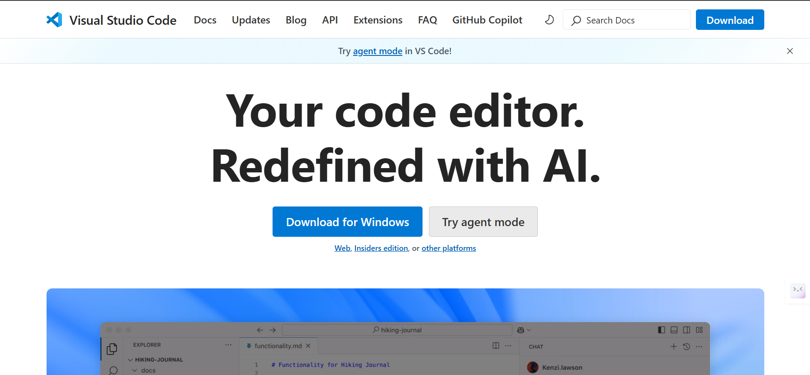

**Step 2:** The setup file should be downloaded as shown in the picture below.

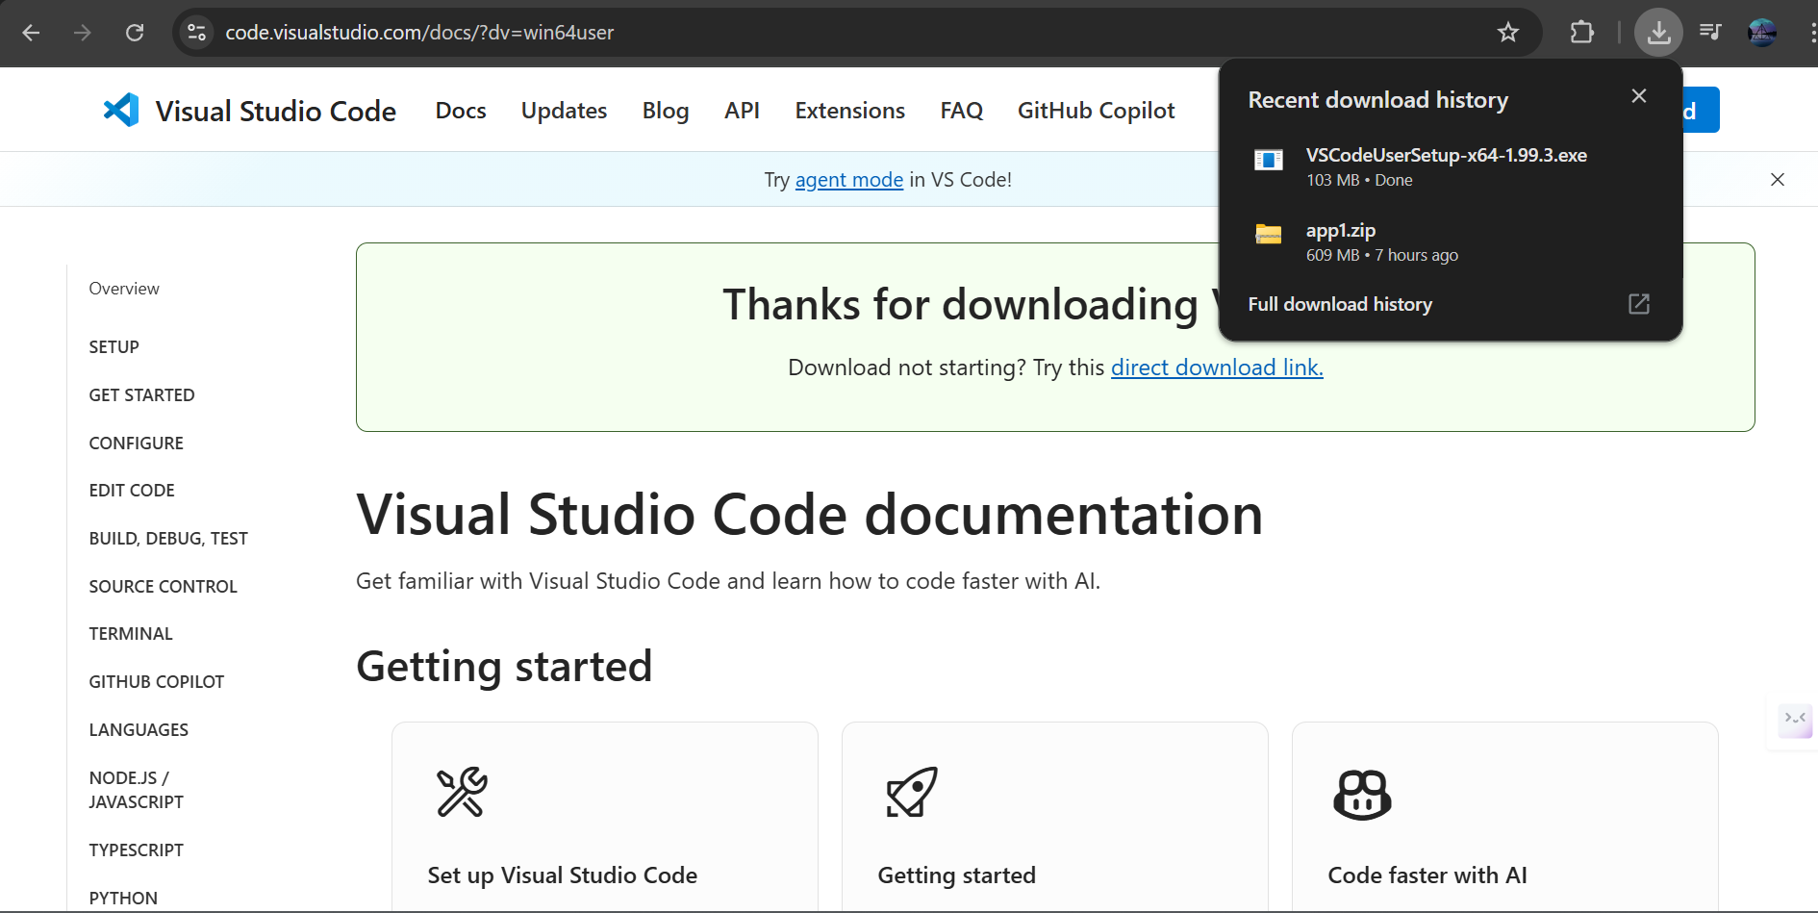

**Step 3:** Now click on “I accept the agreement” and then on Next button.

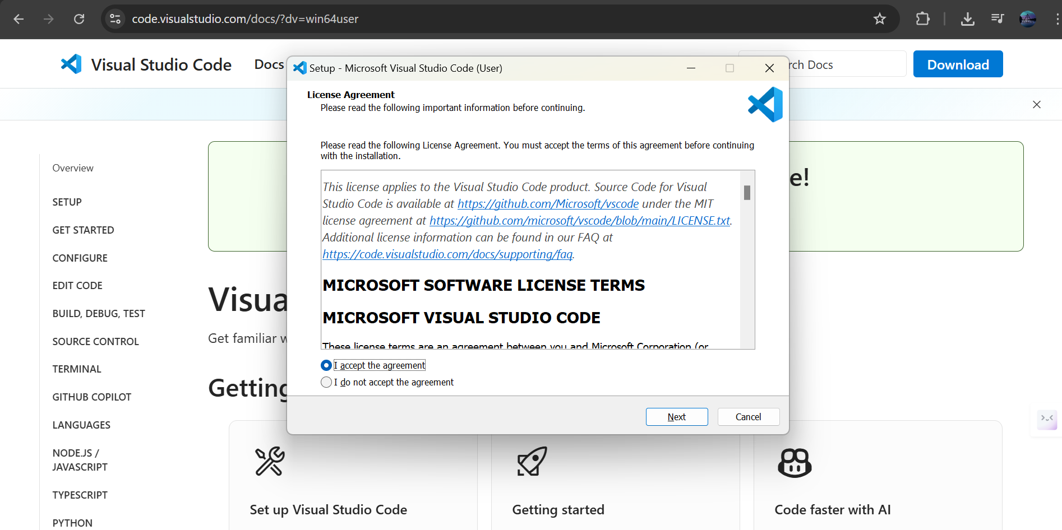

**Step 4:** Select the file destination according to your desire and then click on Next button.

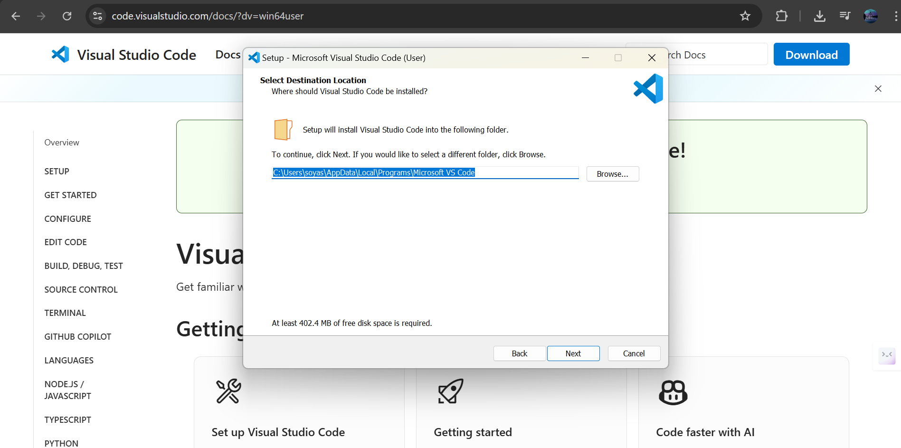

**Step 5:** Click on Next to continue. 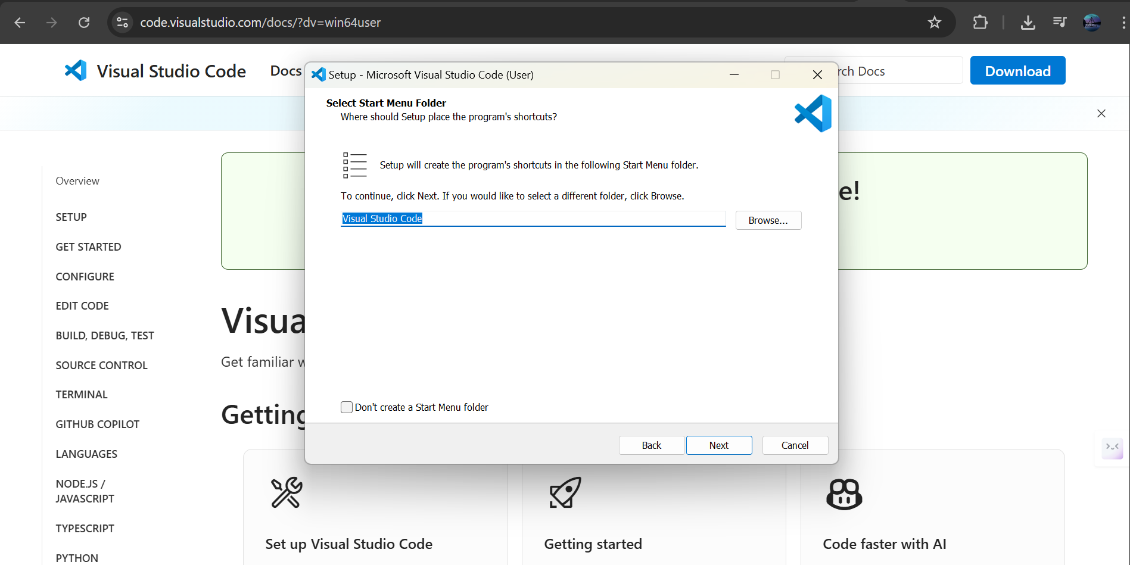

**Step 6:** Leave the default selection or select the additional tasks and then click on Next.

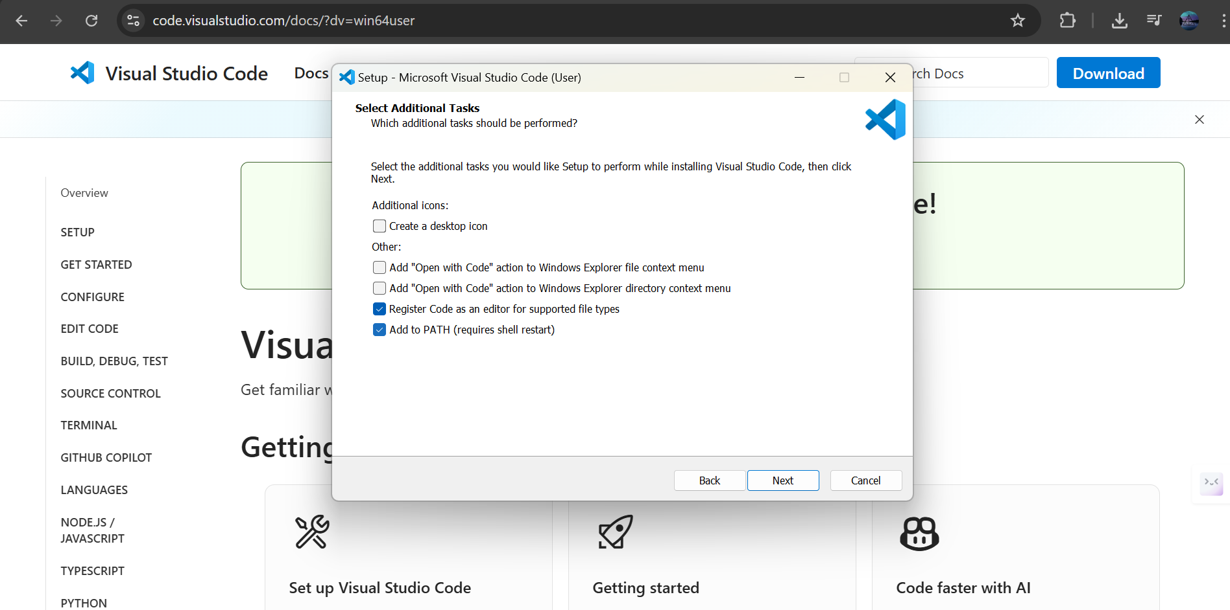

**Step 7:** The setup for Visual Studio is now completed, click on Finish to get started with VS code.

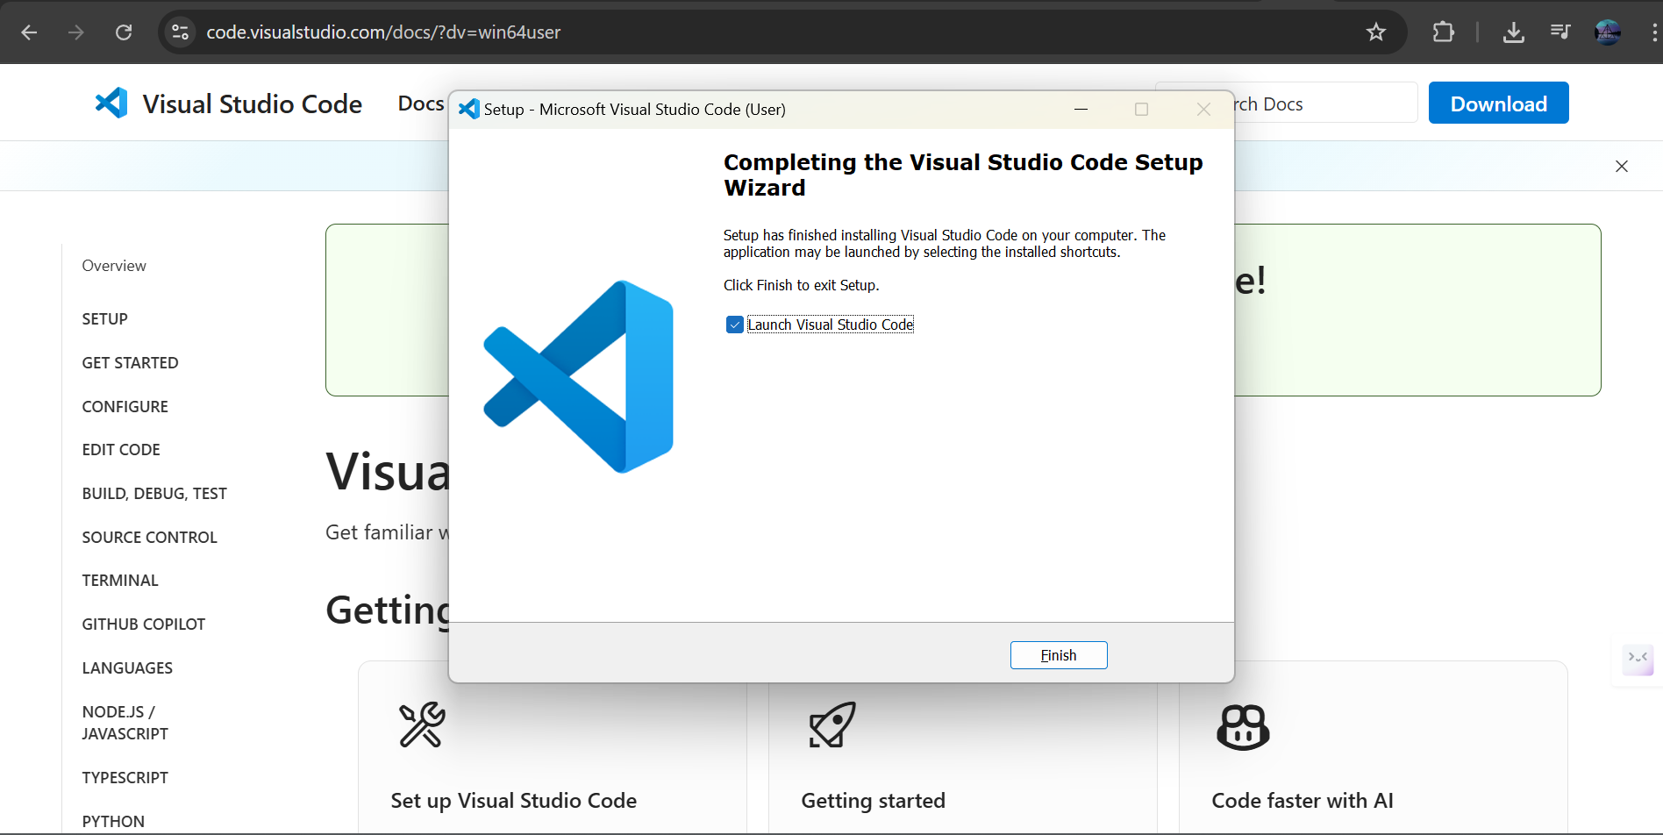

**Step 8:** You can now start with the coding.

